Image | 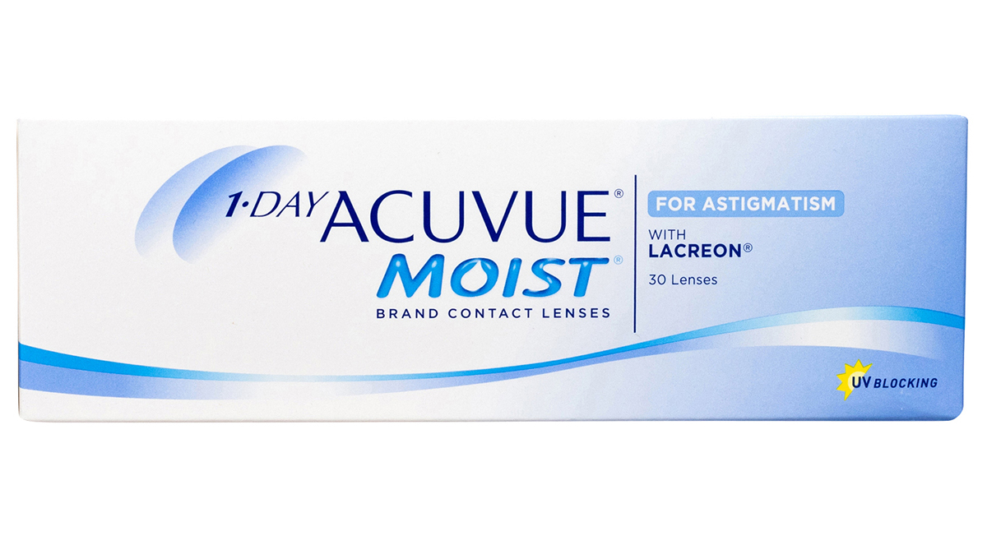
Brand | GUCCI
Model Name | 1-day-acuvue-moist-astigmatism11
Price | RS 2499
PRODUCT DETAILS

